MT  Contact  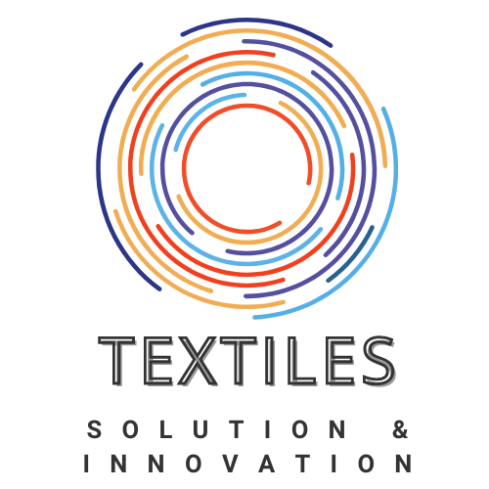  2120 S. State College  Suite #2077  Anaheim, CA 92806  Michael.tanios@textilesinnovation.com  +1 (971) 713-8373 | Michael Tanios  Textiles Solution & Innovation | Consulting Services  Our Services  YARN INNOVATION  - Develop tailored yarn blends that precisely match the desired properties of your end-product.  - Source innovative yarns utilizing adaptive technology for specialized applications.  - Optimize spinning processes to achieve the ideal characteristics for your yarn.  - Implement advanced finishing techniques to enhance yarn performance and quality.  - Customize yarn specifications to balance cost and performance requirements.  - Partner with top-tier yarn mills to meet your specific development needs.  MATERIAL INNOVATION  - Select the optimal fabric system to align with your product's requirements.  - Design and engineer custom yarns tailored for your specific development.  - Define comprehensive specifications for fabric development, including yarn size, machine type, and gauge.  - Conduct thorough cost analysis to identify opportunities for cost reduction while maintaining performance standards.  - Determine the most effective dyeing and finishing parameters for your fabric.  - Identify and conduct necessary performance testing to ensure product quality.  - Maintain open communication with mills to address technical inquiries and troubleshoot development challenges.  - Provide comprehensive supervision during the production launch phase to minimize issues.  CASE STUDY  - Collaborate closely with clients to develop detailed case studies highlighting successful solutions and innovative approaches.  - Focus on areas such as: process development, product development, material customization, productivity optimization, quality control improvement, sustainable practices, cost efficiency, educational initiatives, and employee training.

